Lab 4 Results
RTT Table (PingPong):
Message Size (bytes) | Iterations | Average RTT | Estimated One-Way Latency
1 | 10000 | 0.00001 | 0.00001
8 | 10000 | 0.00001 | 0.00001
64 | 10000 | 0.00001 | 0.00001
512 | 10000 | 0.00001 | 0.00001
4096 | 10000 | 0.00006 | 0.00003
65536 | 10000 | 0.00020 | 0.00010

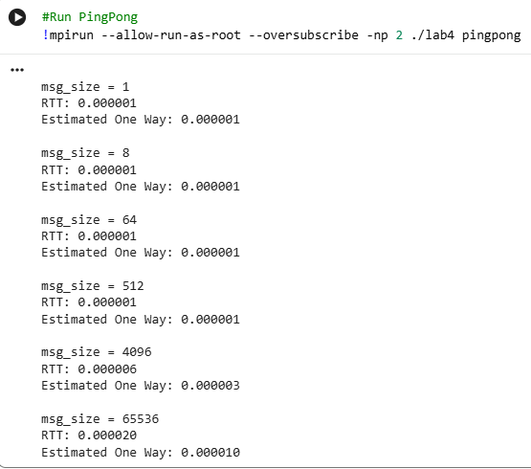

Questions Part A:
1. Why is timing performed on rank 0 only?
Because Rank 0 has to both send and receive to/from Rank 1, the total return time of the message is already included. To time both Rank 0 and Rank 1 would be to essentially double RTT, as both would calculate their send and receive times.

2. Why is RTT/2 only an approximation of one-way latency?
RTT/2 approximates one-way latency because it averages the send and receive times to/from Rank 1. Identical reasoning as above in Question 1.

Questions Part B:
1. Why can this deadlock if all processes execute it simultaneously?
If all processes are sending at the same time, then no professes are receiving, which leads to deadlock.
Conformation of Correct Ring Behavior: 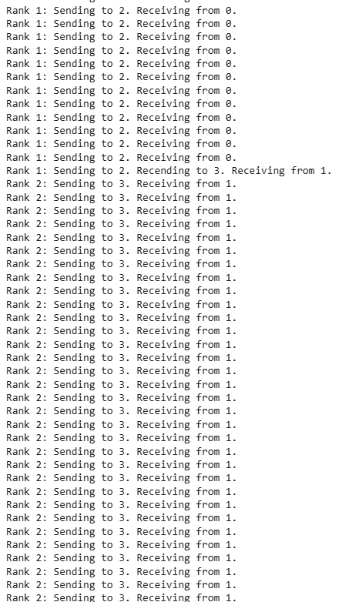
I had to search why it was printing like this, but apparently this is also confirmation that it is working/sending/receiving appropriately, but is just a print buffer design choice – that it prints off similar ranks in bulk, even with flushing the buffer.

